insert your
photo here

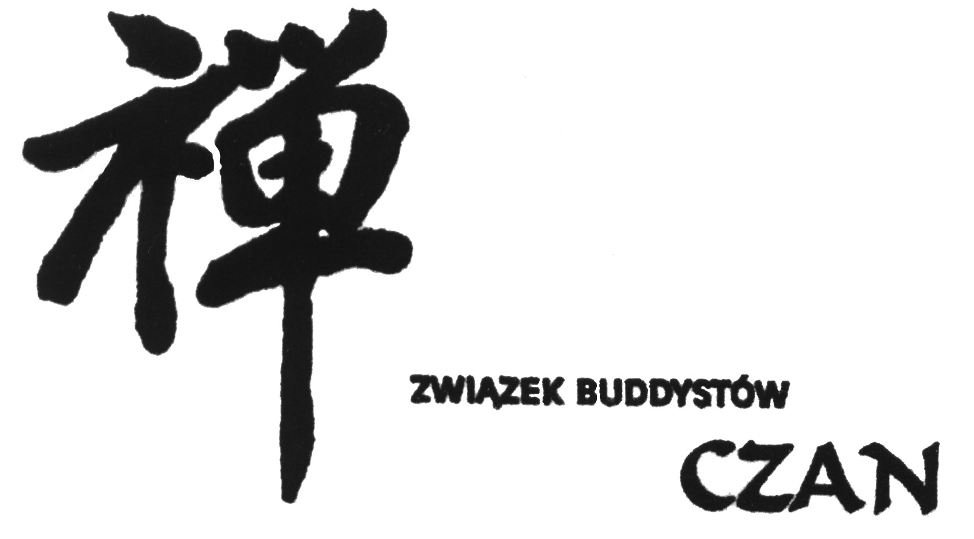

July 17 – August 16, 2025 CH’AN RETREAT APPLICATION FORM
Teacher: Ven. Chi Chern Fashi
The retreat will begin at 7 pm on July 17, 2025, and will end at 10 am on August 16, 2025. It will take place in the Plein-air House of the Academy of Fine Arts in Dluzew.
All information about the teachers, fees, transportation and lodging is included in enclosed material, as well as on our website http://www.czan.eu/en/odosobnienie-czan-sierpien-2025/
The meals at the retreat will be vegetarian. If due to health reasons you have special dietary needs, please let us know.
Please describe any current health concerns (especially those listed below) and medications that may be relevant to your participation in the retreat.
If after sending us this application form, it turns out you cannot take part in the retreat, please let us know as soon as possible.
-----------------
Application form (PLEASE SEND TO THE FOLLOWING ADDRESS: PAWEŁ ROSCISZEWSKI, UL. SOSNOWA 8, 05-540 ZALESIE GORNE, POLAND OR BY E-MAIL TO buddyzm@czan.eu):

I hereby apply to the Ch’an retreat with Ven. Chi Chern Fashi for the following period/periods (please mark appropriate dates, you can choose more than one period):
1. [ ] July 17 – July 26, 3. [ ] August 2 – August 9,
2. [ ] July 26 – August 2, 4. [ ] August 9 – August 16.

1. the 30 day participation fee is 2450 Euro, with a deposit of 1220 Euro;
2. the 23 day participation fee is 1950 Euro, with a deposit of 1420 Euro;
3. the 21 day participation fee is 1800 Euro, with a deposit of 900 Euro;
4. the 16 day participation fee is 1450 Euro, with a deposit of 730 Euro;
5. the 14 day participation fee is 1300 Euro, with a deposit of 650 Euro;
6. the 9 day participation fee is 880 Euro, with a deposit of 440 Euro;
7. the 7 day participation fee is 700 Euro, with a deposit of 350 Euro.

I attended the following retreats:
1. 49 - day retreat: how many times? …... ; leading teacher(s): …..........................................................................................
2. 21- day retreat: how many times? …... ; leading teacher(s): …..........................................................................................
3. 10-day retreat: how many times? ….... ; leading teacher(s): …..........................................................................................
4. 7-day retreat: how many times? ….... ; leading teacher(s): …..........................................................................................
5. 5-day retreat: how many times? ….... ; leading teacher(s): …..........................................................................................
6. …-day retreat: how many times? ….... ; leading teacher(s): …..........................................................................................

I need a lift to Dluzew on July 17: [ ] yes
I need a lift from Dluzew on August 16: [ ] yes

Health concerns that may be relevant to your participation in the retreat:
- Back ailments and similar problems (e.g. strong back pains) that make it difficult to maintain an upright posture.
- Ailments of the legs, hip joints, or knees.
- High or low blood pressure.
- Heart problems.
- Serious surgery undergone directly before the retreat.
- Seriuos allergies.
- Contagious diseases.
- Serious emotional or mental disorders.
- Disturbing physical symptoms that tend to appear in meditation, e.g. headache, vertigo, heart palpitations, short breath etc.

Personal data

Name: |  | Gender: M / F
Date of birth: | Email:
Address:

Phone: | Mobile phone:
Name and phone of person to be contacted in case of emergency, e.g. illness/accident:

I hereby declare that I have given valid information about my state of health and that I am participating in the retreat at my own responsibility, i.e. I will not hold neither Zwiazek Buddystow Czan nor any person leading the retreat liable for any potential illness or accidents suffered by me during the retreat. I commit to respect the retreat guidelines and schedule being aware that a serious violation of the guidelines may result in leaving the retreat. I have read the list of health problems above and declare that I do not suffer from any illnesses that could prevent my participation in the retreat. I agree to the processing of personal data provided in this document for realising the retreat qualification process pursuant to the Personal Data Protection Act of 10 May 2018 (Journal of Laws 2018, item 1000) and in agreement with Regulation (EU) 2016/679 of the European Parliament and of the Council of 27 April 2016 on the protection of natural persons with regard to the processing of personal data and on the free movement of such data, and repealing Directive 95/46/EC (General Data Protection Regulation).

Date/Signature: ___________________________________

